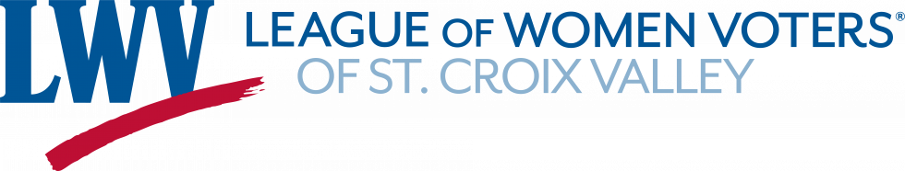OUR MISSION: Empowering Voters. Defending Democracy

September 15, 2023

Next week is National Voter Registration Day. Following is a great opportunity for members to hear from our leadership at the state level:

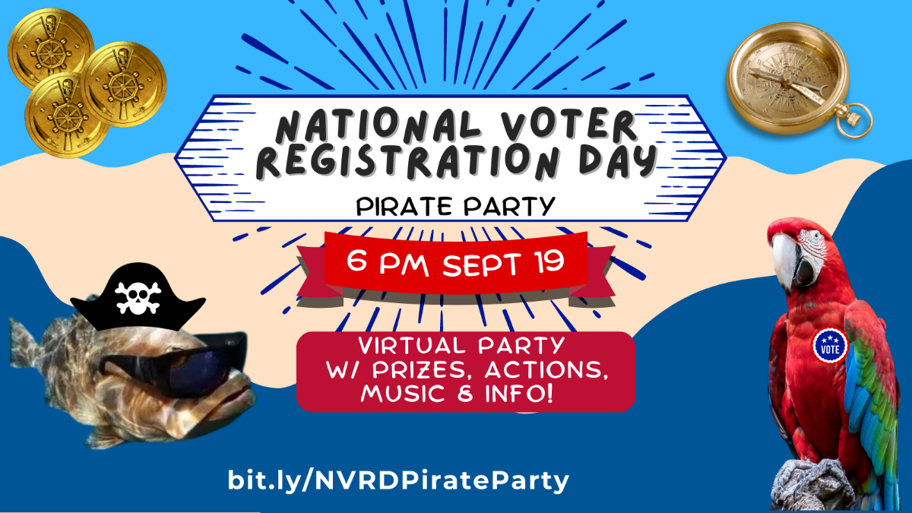
Ahoy!
Join us on the high seas of civic engagement for an unforgettable virtual event on National Voter Registration Day (which also happens to be National Talk Like a Pirate Day)! Mark your calendars for
6:00 p.m. Tuesday, September 19
and prepare to embark on an adventure that will empower you to seize your freedom to vote. Arrr… you ready to register? We can promise fun and information, but we can't promise that we'll slow down on the pirate puns!
(cont.)
Register: bit.ly/NVRDPirateParty

What to Expect:
- Stories on the importance of voting
- Answers on your voter registration questions
- Create and share fun content about voter registration
- Sessions to text friends with info
- Opportunities to win merch and prizes

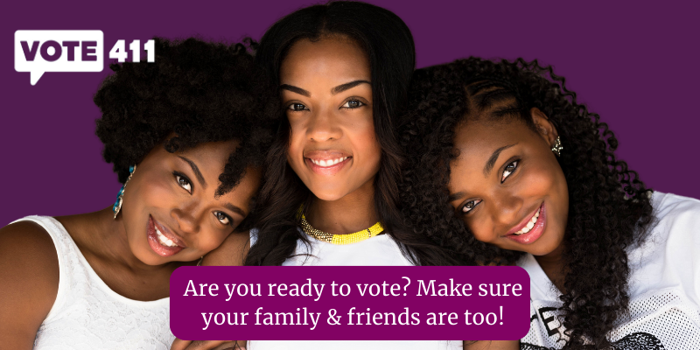
Using Our Voices in Our Own Communities!

Our most important outreach effort comes from you, a League member. Yours is the League face in your community Through casual conversations and sharing of information you can support and encourage trust in the election process. You can promote democracy close to home. As we all know, information from a trusted friend or known colleague is valued beyond all the data and fact sheets that may be accessed at will.
It is essential that League members amplify our nonpartisan message to support the democratic process. It is essential that voters have clear and nonpartisan information about elections and the election process in Wisconsin. Too much disinformation has been spread to smear the integrity of our election process. It is up to every single one of us to share solid information to those closest to us.
How do you get started?
To find ways of messaging, even in single conversations with our neighbors, be sure to reference the tool kit offered by the State League. Follow the link below to gain confidence in your own ability to educate and encourage your friends, family, and neighbors to have a clear understanding of the quality of our local election boards, and the election process in the state as a whole:
Follow the link below to find a wealth of information to help you ‘spread the message’ of confidence in our elections.

Building Confidence in Our Elections (a LWV-WI toolkit)
https://lwvwi.us1.list-manage.com/track/click?u=28ea86dd7c46f5cfdcf3e4a00&id=310bf461c2&e=00033bfe81

Action Item for LWV SCV members

Do you know about Final Five Voting? Are you enthused about the potential of Final Five Voting to improve the election process in Wisconsin?
If so, be sure to share your opinion with our elected officials.
For those who have not filled out a physical postcard already, please use the link below to ask your elected officials to support Final Five Voting by completing this form.
By filling out this form, you are authorizing one of the GROWW volunteers to hand-write your statement and print your name on the physical postcards we are sending.
Thank you so much for your support! Together we can make Wisconsin a better state for our voters and our representatives!

https://forms.gle/cjNBJkv4h1y1nTBUA
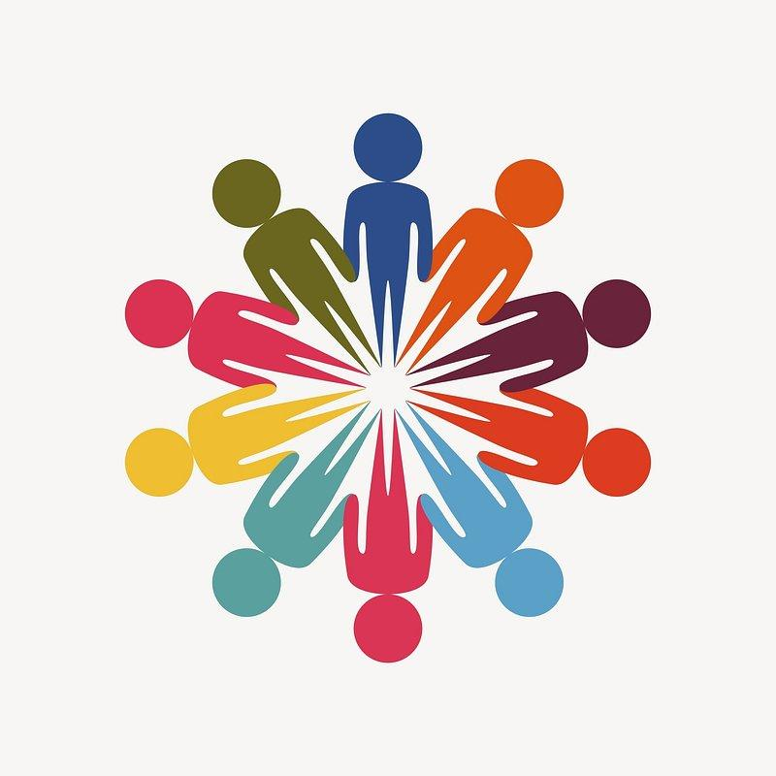

Reminder:
LWVSCV – Board and Committee Chair Meeting via Zoom – (check your email)
Sept. 19, at 4:00 p.m.
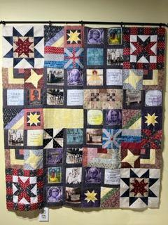
Suffragist Quilt Donation
We would like to extend a heartfelt thank you to Carol Johnson. She has been a member of LWV SCV since April of 2022. She contacted our league wondering if we might be interested in a quilt that she was designing using suffragist blocks. We replied with a resounding YES!
She sent a photo from her design wall and also gave the following information: Some of the blocks have photos. They include Lucretia Mott, Carrie Chapaman Catt, & Elizabeth Cady Stanton. Others have quotes. They are by Elizabeth Cady Stanton, Anna Julia Cooper, Ida B Wells, Emmeline Pankhurst, Amelia Bloomer, Susan B Anthony, Sojourner Truth, Carrie Chapman Catt, & Francis Watkins Harper. There are other fun photos at protests.
Carol’s generous quilt donation was made with no strings attached. We can use the quilt to raise funds through a silent auction or raffle or keep it to use at League events. Last year, Carol donated a bargello Christmas-themed quilt to the Chippewa Falls League. This quilt was just raffled off at their Women’s Equality Day event in Menomonie on Augst 26.
Carol was thrilled to learn that our Program Committee headed by Vicki Harmon is planning a Reader’s Theater production for Fall, 2024 about the 19th amendment, voting rights and voter suppression. The Suffragist Quilt is a perfect fit.
Carol plans to complete the quilt soon. We look forward to displaying it at upcoming League events, including the Reader’s Theater performances next fall.

Volunteer Opportunity!
Know Your Nonprofits Expo October 5, 2023 5-7PM
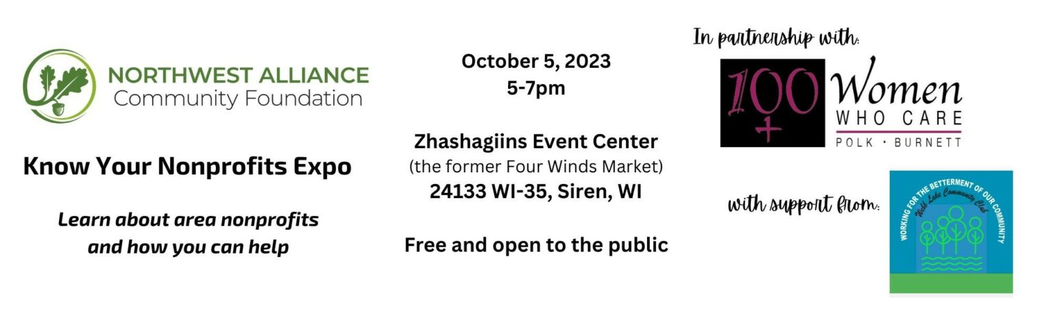
Launched in 2013, Know Your Nonprofits is an annual event open to the public hosted by Northwest Alliance Community Foundation in partnership with 100+Women Who Care of Polk and Burnett County.
LWVSCV has been invited to participate. This is a great opportunity for our message to get out to the public and to network and explore connections with other nonprofits in Polk and Burnett Counties.
Have you an hour or two to donate to this fun event? We are looking for volunteers to help with on site presence for set up, clean up, and/or sharing the LWVSCV story and networking with other members from Polk and Burnett County during the Expo.
Interested? Email Kris at aksurbaugh@gmail.com or call 715-566-1186.
Something to keep in mind as we are out in our communities:

The League is proud to be nonpartisan, neither supporting nor opposing candidates or political parties at any level of government, but always working on vital issues of concern to members and the public.

OUR MISSION
Empowering Voters. Defending Democracy.

OUR VISION
We envision a democracy where every person has the desire, the right, the knowledge and the confidence to participate.

OUR VALUE
We believe in the power of women to create a more perfect democracy.

Interested in moving into a new position in the League? Find a committee that fits your skills and passion:

Member Services–Committee Contacts
- Voter Services
- Get Out The Vote Events
- Voter Registration Events
- Meet The Candidate Events
Patty Van Nevel: pattyvannevel@gmail.com
Rita Kearns: ritakearns54@gmail.com

Member Services
- Member Enrichment Events
- Member Recruitment
- Manage Recruitment materials in
- public places
Marla Olson: msoolson54@gmail.com
Nanette Del Monaco: nanettedm@gmail.com

Program Committee
- Social Events (Annual Meeting, Summer Picnic)
- Education Programs
- Special Events
- Reader’s Theater
- Book Study
Vicki Harmon: vickiharmon@gmail.com

Communications & Media
- Website & Social Media
- Newsletter
- Press Releases & Research Writing
Kris Surbaugh: aksurbaugh@gmail.com

Budget Committee:
- Budget Development & Oversight
- Fundraising
Nancy Stewart: N.Stewart@yahoo.com

Grass Roots Organizers of Western Wisconsin– a non-profit, nonpartisan collaborative partner to LWVSCV

